**ATS Process – Remove user from Distribution lists**

**Task names: Remove Users from the DL's**

|  |  |
| --- | --- |
| **Autor: Eduardo Osuna** | **Account: Trinity** |
| **Version: 1.0** | **Document type: Knowledge** |
| **Creation Date: 03/28/2021** | **Last Modification:** |
| **Owner: Eduardo Osuna** | **Last Modification made by:** |

**ATS Process – Remove user from Distribution lists**

TASK NAME: Remove [User] from DLs

Listed below are the DLs that we can remove users from:

1. DL-CAN-Contractors

2. DL-CAN-Employees

3. DL-Dallas1099Contractors Only

4. DL-Dallas1099 Employees Only

5. DL-MEX-Contractors

6. DL-MEX-Employees

7. DL-USA-Contractors

8. DL-USA-Employees

**Find User:**

1. First Open Microsoft Outlook and head to the option “Address Book” on the options ribbon “Home”.

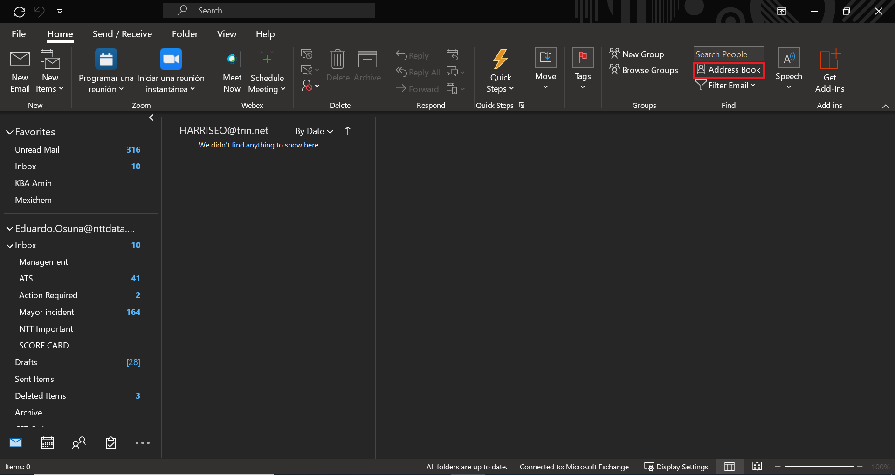

1. On the search bar type user’s name. No need to click on enter sine the application would immediately show all the approximate results.

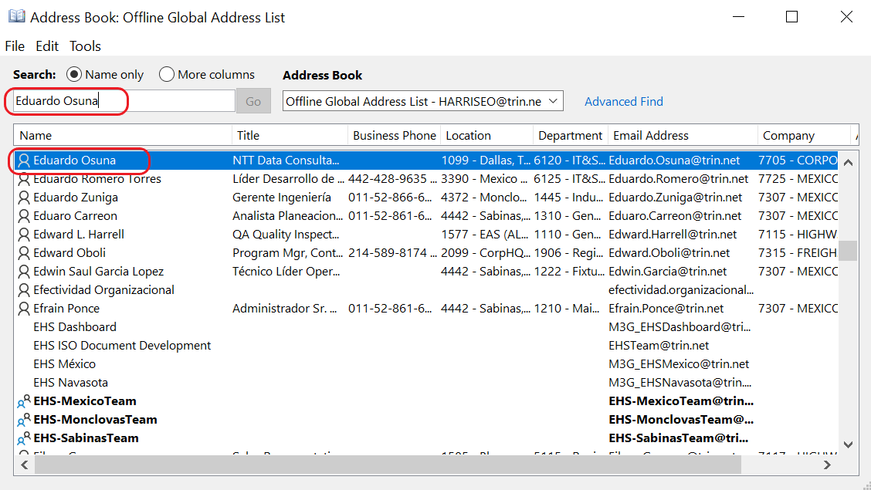

**Check Membership:**

* Double click on the user’s name to get into the user’s profile card and click on “Member Of” Tab.  
    
  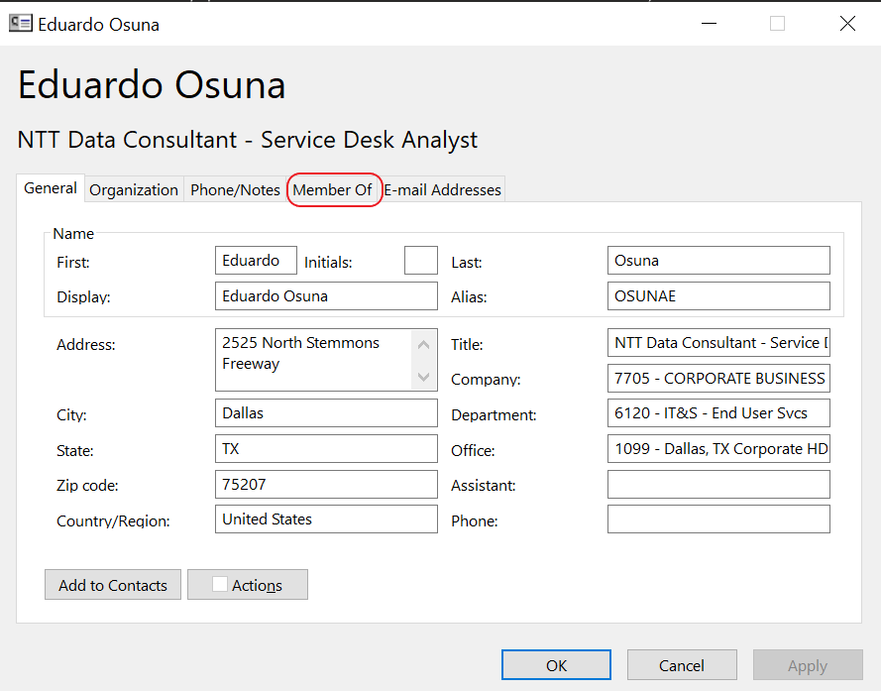
* As per the listed Distribution lists mentioned at the beginning of this document locate the Lists the user is member of.  
  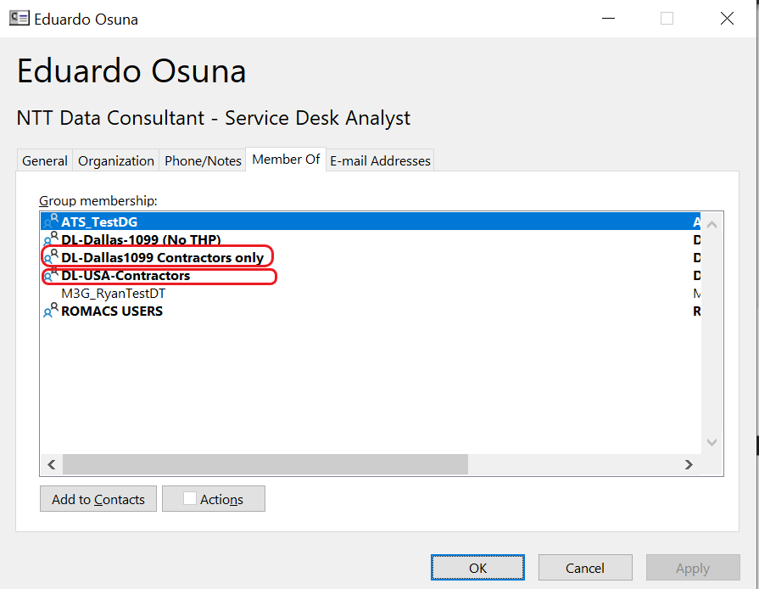

**Removal Process**

1. Double on the Distribution list name so its information is displayed.
2. On the “Members” square you will find a list of the users added to the selected distribution list. Click on “Modify Members…” to open the “Contact Group Membership” list.  
     
   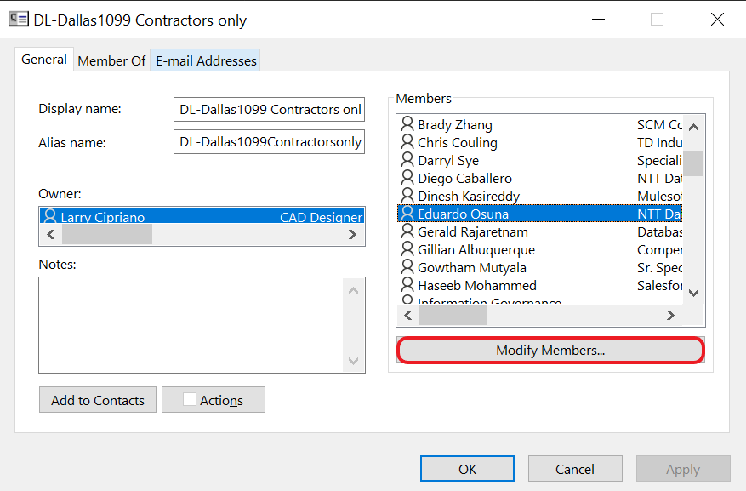
3. Locate the user that needs to be removed by scrolling down or up or by typing the user’s name on the “Contact Group Membership” list. Afterwards click on the button “Remove”.  
     
   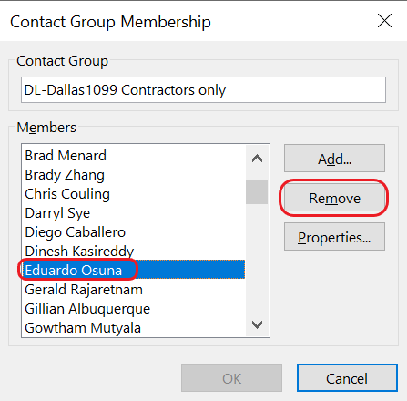
4. Repeat the process with all the Distribution lists the user is member of. **Remember** to only apply this procedure on the Distribution lists mentioned at the beginning of this document.
5. When entering the closure notes on your task remember to enter user name and the distribution lists he/she was removed from.  
     
   “- User Eduardo Osuna has been removed from the following distribution lists:  
   DL-Dallas1099Contractors Only  
   DL-USA-Contractors”